Post-Lab 1: Wireshark and your local network

## What to submit?

Please use this document as a template, add your responses directly, and export it as a PDF to Gradescope. For this lab, each student should submit their own report.

Name: Rajan Verma

Student ID:A69028626

C: Wireshark Practice

**Show a screenshot of your captured HTTP request/response:**

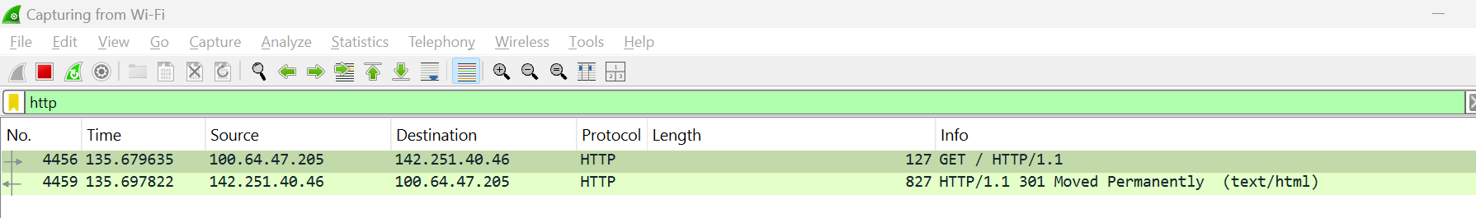

**from cmd prompt :**

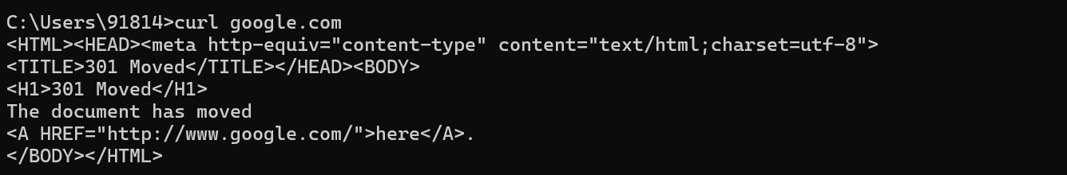

**Show a screenshot of your captured DNS request/response:**

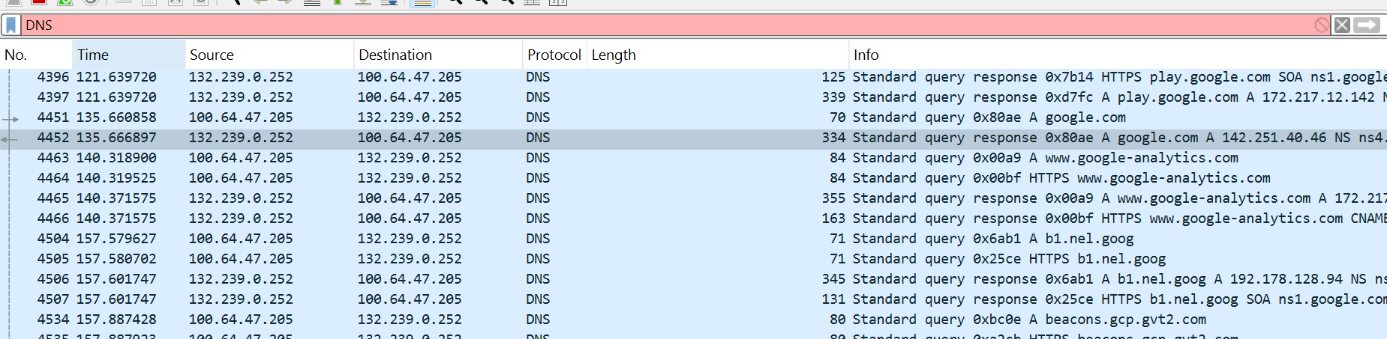

D: Inspect Ping Traffic

**Show a screenshot of your captured *ping* traffic:**



**What does “ICMP” stand for?**

 Internet Control Message Protocol : sends error messages when data transmission fails

**For one of your ping packets, start from the PHY and list each of the layers that were used to send the packet, and which technology was used.**

* **Ping is initiated.**
* **Phy Layer : Wifi handles physical layer.**
* **Datalink Layer : Wifi and Ethernet.**
* **Network Layer : Ipv4-v6, TCP IP Protocol.**
* **Transport Layer : ICMP**

E: Investigate Intentional Traffic

**Show a screenshot of your captured *netcat* traffic from both you as a listener and as a sender. Clearly document which case is which.**

**As a Sender :**

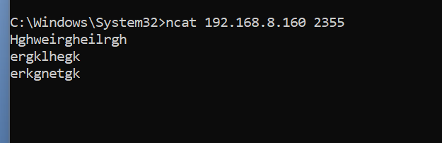

**As a Reciever :**

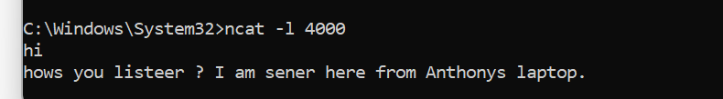

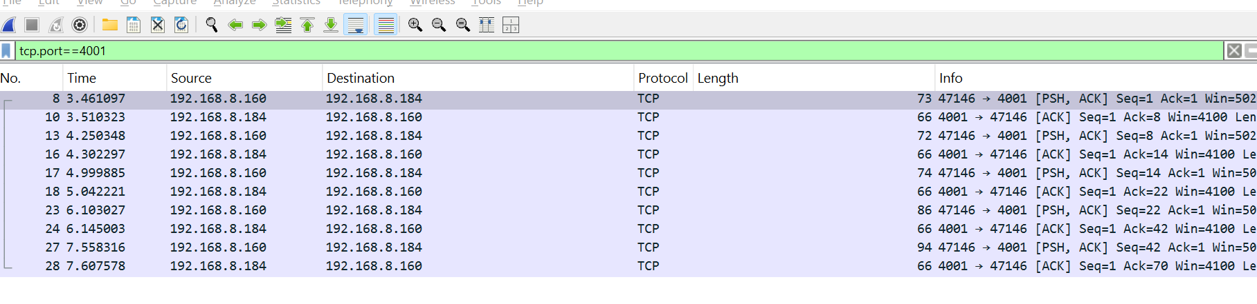

**Can you see other *netcat* traffic from other students in the class? Why or why not?**

**I cant see from other students apart from Anthony since they have left. If others students were here and connected then it would show up on the wireshark.**

**Imagine you were having a *netcat* conversation with a friend at George Mason. Besides you and your friend, who else could see the contents of your conversation?**

**Yes the packets are visible as a TCP protocol data. Then we need to convert the ASCII codes to make it human readable. Netcat doesnt encrypt so spying or snooping or hearing is easily possible.**

# 

# F: Discover WiFi Networks Around You

**What is the name of the WiFi network we set up?**

**tock_tutorial**

**What are the types of probe packets that you see?**

**I tried to install npcap and with monitor mode enabled but somehow in wireshark even in administer mode I get greyed out at monitor mode for the Wifi :  
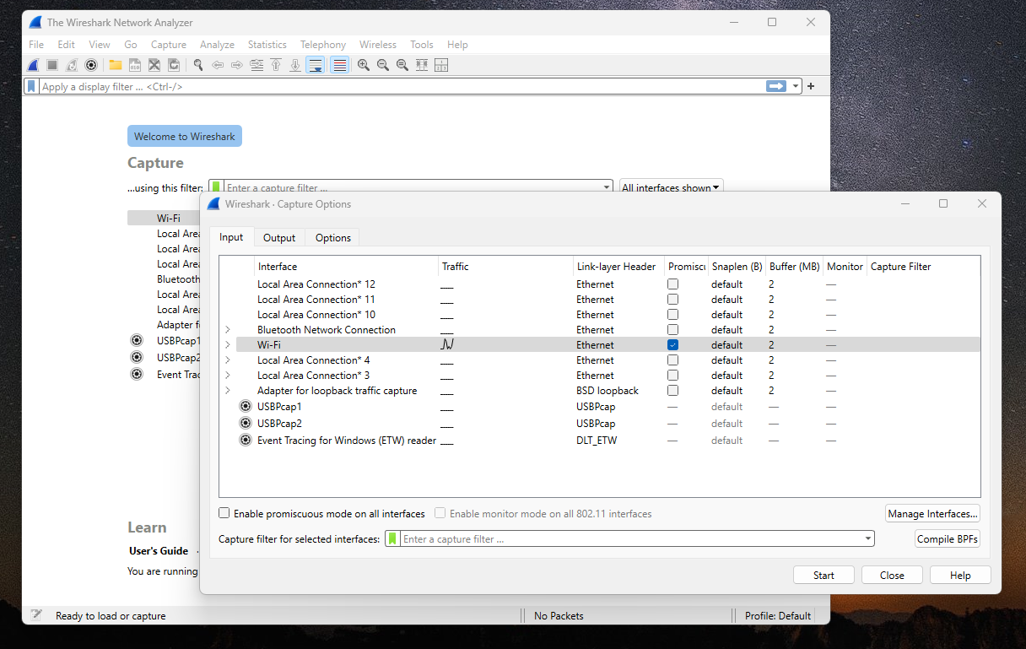**

**What I see is**

**What filter did you use to see only packets from our test network?**

**to see probe packet I would have used this:**

**wlan.fc.type_subtype == 0x5 || wlan.fc.subtype ==0x4**

**What is the MAC address of the router for the test network?**

**Since I am doing this from home now, my hoime wifi is , please see the green highlighted.**

